Reference: [IBPSA Conference PapersLinks to an external site.](https://publications.ibpsa.org/conference/?id=bs2023) <https://publications.ibpsa.org/conference/?id=bs2023>

Interim 1 -- BPS5231 Artificial Intelligence for Sustainable Building Design

**Abstract**

As the intelligence level of building environments increases, optimizing lighting system energy consumption and regulating individual comfort have emerged as promising research topics in building performance studies. Currently, building lighting primarily relies on centralized background systems for unified control, yet such systems struggle to accommodate individual preferences. Meanwhile, Personalized Environmental Control Systems (PECS) enable each occupant to adjust their microenvironments according to personal needs, yet lack coordination mechanisms with the overall system. Addressing this contradiction, this paper proposes a balanced light control framework that integrates background systems with PECS. This framework aims to achieve dual optimization of visual comfort and lighting energy consumption under varying occupancy conditions.

This research focuses on the light environment because lighting acts as a crucial component of indoor environments. We utilize ClimateStudio to simulate comfort and energy consumption through relatively intuitive visualization methods. This provides a foundation for broader, more in-depth future research. The study first constructs a simulated lighting environment based on the 3D building model of a real office room and random occupancy distribution data. The background system and PECS parameters are set as decision variables. An optimizer evaluates lighting energy consumption and visual comfort metrics to generate optimal control strategies. Building upon this, the paper further combines optimization results under multiple occupancy distributions to construct training dataset pairs. An agent model is trained to quickly and accurately predict optimal control strategies. Finally, case studies uses historical occupancy data from real office buildings to compare energy consumption differences between traditional centralized control and the balanced control model.

Results indicate that, … TBD Hopefully good :)

Keywords: *Indoor lighting comfort, balanced PECS and background control, energy saving, multi-object optimization, ML-based surrogate model*

**Introduction & Related Works**

In smart building performance research, balancing lighting system energy optimization with visual comfort remains a critical issue in building environmental control. Lighting not only directly impacts occupants' visual perception and work efficiency but also accounts for a significant proportion of overall building energy consumption. As building intelligence advances, traditional centrally controlled background lighting systems increasingly struggle to meet diverse occupant needs. Concurrently, Personalized Environmental Control Systems (PECS) have been introduced into office and educational spaces, enabling individuals to actively adjust their local microenvironments—such as task lighting and radiant temperatures—to enhance comfort and satisfaction (De Korte et al., 2015). However, current building lighting control strategies remain predominantly centralized, lacking systematic research on the synergistic relationship between PECS and background systems.

In real-world office environments, occupancy exhibits highly dynamic temporal and spatial characteristics. Changes in occupancy density, distribution, and dwell time directly influence building energy consumption patterns and lighting demands (Tekler et al., 2022). If lighting systems fail to flexibly adjust to occupancy variations, issues like “localized over-illumination” or “energy waste” readily occur. Existing research often focuses on optimizing individual systems, such as adjusting central lighting based on occupant counts (Lesina Debiasi, 2020) or evaluating PECS usage preferences and effectiveness (Papinutto et al., 2021). However, few studies explore joint optimization strategies for both systems under dynamic occupancy conditions at an integrated level. This results in potential imbalances between energy consumption and comfort in actual building lighting operations.

This study adopts the light environment as an entry point, serving as an initial pathway to explore the synergy between personalized and systemic controls. Compared to complex variables like thermal environments or air quality, simulating lighting conditions offers greater intuitiveness and quantifiability. It enables clearer visualization of the coupling relationship between energy consumption and comfort, thereby providing a validation framework for subsequent multi-factor integrated control research. Based on this, this paper proposes a Balanced Light Control Framework. By integrating a central background system with personalized lighting control (PECS), it achieves an optimized balance between minimizing energy consumption and maintaining visual comfort under varying occupancy distributions.

To achieve this objective, the study first constructs a three-dimensional light environment simulation model incorporating building geometry and occupancy distribution parameters. Illuminance outputs from the background system and PECS serve as decision variables, while lighting energy consumption and visual comfort act as optimization targets. Employing a constrained approach within a multi-objective optimization framework, the primary goal is energy consumption minimization, constrained by illuminance comfort thresholds, to generate optimal control strategies for diverse occupancy scenarios. Subsequently, the optimization results are expanded into multiple input-output samples. Machine learning techniques are employed to establish a surrogate model, enabling rapid inference of optimal lighting control schemes under new occupancy distribution conditions. Finally, the framework's applicability and energy-saving potential under dynamic occupancy scenarios are validated using historical occupancy data from the real-world office building BEE Hub (Tekler et al., 2022). The findings provide a novel technical pathway for integrating personalized and system-level lighting control, while also offering a scalable approach for occupancy-behavior-driven environmental control optimization in smart buildings.

**Methodology**

The overall methodology of this study is illustrated in the figure with six main components: environmental inputs, decision variables, objective variables, optimization, surrogate model construction, and case validation.

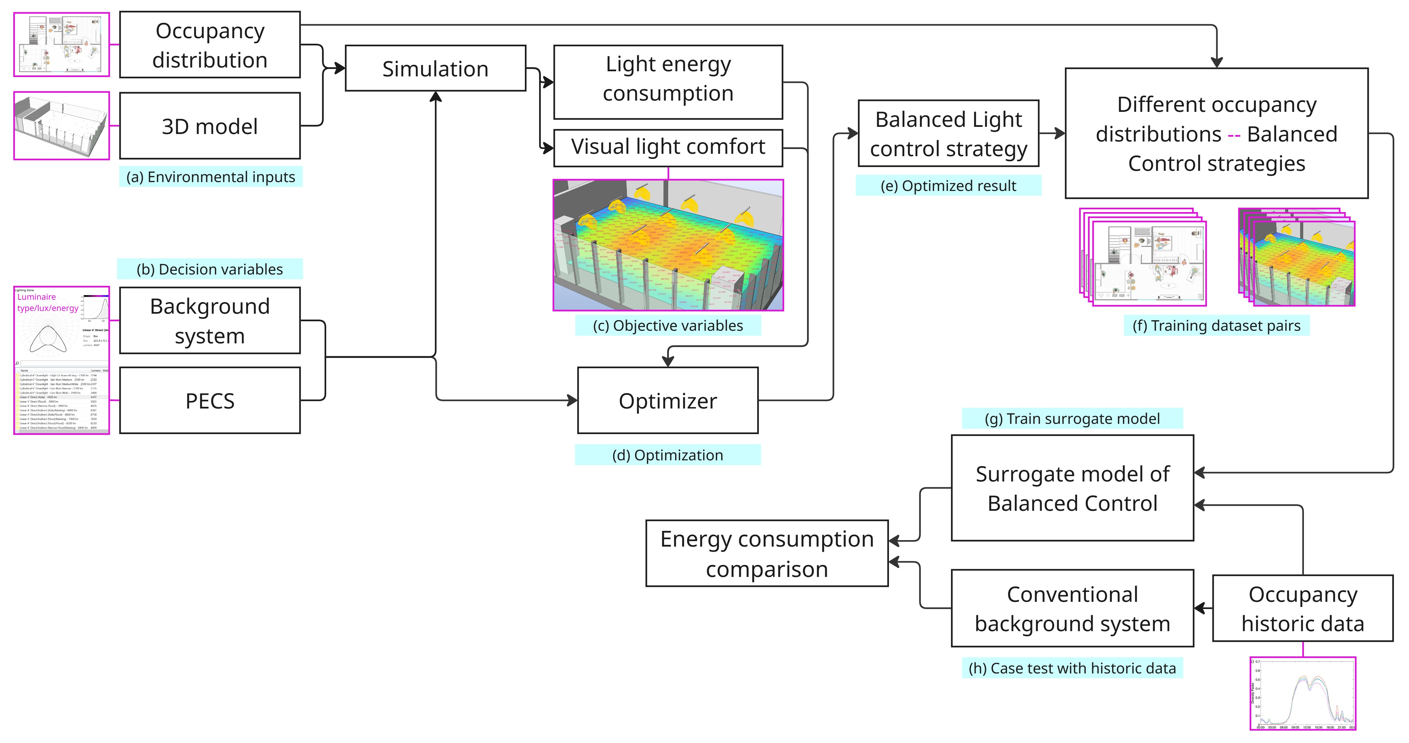

*fig.i Methodology Illustration. (a) - Environmental Inputs, (b) - Decision Variables, (c) - Objective Variables, (d)&(e) - Optimization Process, (f) & (g) - Surrogate Model Construction, (h) Case Validation*

(1) Environmental Inputs

A real office space (BEE Hub) was selected as the study subject. Based on a 3D building model, spatial geometric boundaries, material properties, and lighting fixture layouts were defined. Simultaneously, randomly generated occupancy distributions were employed as environmental input parameters to simulate occupancy variations across different time periods and density levels.

(2) Decision Variables

Control variables were the overall illuminance level of the central background lighting system and the local brightness settings of the PECS. These variables determined the spatial distribution of illumination and the overall energy consumption level.

(3) Objective Variables

Lighting environment simulation was performed by ClimateStudio, outputting metrics including lighting energy consumption and visual light comfort calculated based on specific occupancy distributions. The comfort metric is derived from a comprehensive assessment of work surface illuminance.

(4) Optimization Process

This study adopts dual optimization objectives of lighting energy consumption and visual light comfort, seeking a balanced relationship between them within a multi-objective optimization framework. In practice, a constrained single-objective optimization method was employed: minimizing lighting energy consumption as the primary goal while setting visual comfort thresholds as constraints. The optimizer iteratively adjusted control parameters for background systems and PECS during simulation cycles until optimal solutions were obtained. The outcome indicates balanced light control strategies tailored to varying occupancy distributions.

(5) Surrogate Model Construction

For optimization results under various occupancy distributions, training data pairs (Occupancy Distribution – Balanced Strategy) were generated. A machine learning model was employed to establish a surrogate prediction framework.

(6) Case Validation

Using historical occupancy data from a real office space (BEE Hub) as input (Tekler et al., 2022), the energy consumption differences between traditional background systems and the balanced control strategy are compared. This evaluates the energy-saving potential and computational efficiency of the proposed method.

**AI Acknowledgement**

Use ChatGPT to help understand the optimization process.

Use DeepL for accurate expression.

**Reference**

De Korte, E. M., Spiekman, M., Hoes-van Oeffelen, L., Van Der Zande, B., Vissenberg, G., Huiskes, G., & Kuijt-Evers, L. F. M. (2015). Personal environmental control: Effects of pre-set conditions for heating and lighting on personal settings, task performance and comfort experience. *Building and Environment*, *86*, 166–176. https://doi.org/10.1016/j.buildenv.2015.01.002

Lesina Debiasi, L. (2020). *Illuminating Preference: Rethinking Colored Lighting in Workplace Environments* [Thesis, Massachusetts Institute of Technology]. https://dspace.mit.edu/handle/1721.1/130183

Papinutto, M., Colombo, M., Golsouzidou, M., Reutter, K., Lalanne, D., & Nembrini, J. (2021). Towards the integration of personal task-lighting in an optimised balance between electric lighting and daylighting: A user-centred study of emotion, visual comfort, interaction and form-factor of task lights. *Journal of Physics: Conference Series*, *2042*(1), 012115. https://doi.org/10.1088/1742-6596/2042/1/012115

Tekler, Z. D., Ono, E., Peng, Y., Zhan, S., Lasternas, B., & Chong, A. (2022). ROBOD, room-level occupancy and building operation dataset. *Building Simulation*, *15*(12), 2127–2137. https://doi.org/10.1007/s12273-022-0925-9